***Heaven’s Light is Our Guide***

|  |
| --- |
| **Rajshahi University of Engineering & Technology**  **Department of Electrical & Computer Engineering**  ***LAB REPORT*** |
| * ***Course title(Sessional) : Digital Techniques Sessional*** * ***Course Code***  ***: ECE-2112*** * ***Date of submission : 06/01/2025*** |
|  |

|  |  |
| --- | --- |
| **Submitted By :** | **Submitted To :** |
| ***Name : Sanumong Marma***  ***Roll : 2210061***  ***Reg no. : 1115***  ***Series : 22***  ***Department of ECE, RUET*** | ***Md. Omaer Faruq Goni***  ***Assistant Professor***  ***Department of ECE,***  ***RUET*** |

**Experiment name:** Explaination of logic gates with necessary figures and truth table.

**Theory:**

A logic gate is a fundamental building block of digital circuits, designed to perform basic logical operations that are essential for digital electronics. These gates are integral to many modern electronic devices, such as smartphones, tablets, and memory devices.Logic gates operate by processing digital signals at their inputs to produce a specific output. Typically, a logic gate has two inputs and one output, all of which are binary (0 or 1). The functioning of these gates is governed by Boolean algebra, where 0 represents false or off, and 1 represents true or on. At any given time, each terminal of a logic gate exists in one of the two binary states: 0 or 1. The output depends on the type of logic gate and the combination of input values. Logic gates are often compared to light switches: in one state, the output is off (0), and in another state, it is on (1).These gates are commonly embedded in integrated circuits (ICs), making them essential for a wide range of digital applications.

Basic Logic Gates : AND, OR, NOT, NAND, NOR.

(i)AND Gate

The AND gate is named so because, if 0 is false and 1 is true, the gate acts in the same way as the logical 'and' operator. The output is 'true' when both inputs are 'true.' Otherwise, the output is 'false.' In other words, the output is 1 only when both inputs are 1.

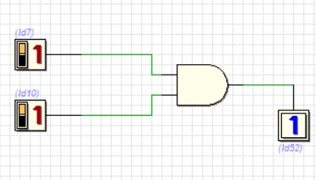

Fig. AND

Truth table:

|  |  |  |
| --- | --- | --- |
| INPUT | INPUT | OUTPUT |
| 0 | 0 | 0 |
| 0 | 1 | 0 |
| 1 | 0 | 0 |
| 1 | 1 | 1 |

(ii)OR Gate

The OR gate gets its name from behaving like the logical inclusive 'or.' The output is true if one or both of the inputs are true. If both inputs are false, then the output is false. In other words, for the output to be 1, at least one input must be 1.

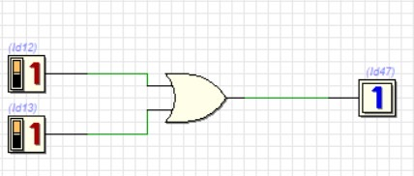

Fig. OR

Truth table:

|  |  |  |
| --- | --- | --- |
| INPUT | INPUT | OUTPUT |
| 0 | 0 | 0 |
| 0 | 1 | 1 |
| 1 | 0 | 1 |
| 1 | 1 | 1 |

(iii)NOT Gate

A logical inverter, sometimes called a NOT gate to differentiate it from other types of electronic inverter devices, has only one input. A NOT gate reverses the logic state. If the input is 1, then the output is 0. If the input is 0, then the output is 1.

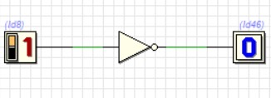

Fig. NOT

Truth table:

|  |  |
| --- | --- |
| INPUT | OUTPUT |
| 0 | 1 |
| 1 | 0 |

(iv)NAND Gate

The NAND (Negated AND) gate operates as an AND gate followed by a NOT gate. It acts in the manner of the logical operation 'and' followed by negation. The output is false if both inputs are true. Otherwise, the output is true. Another way to visualize it is that a NAND gate inverts the output of an AND gate.

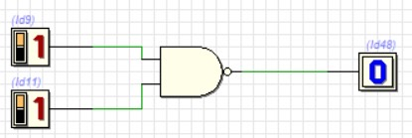

Fig. NAND

Truth table:

|  |  |  |
| --- | --- | --- |
| INPUT | INPUT | OUTPUT |
| 0 | 0 | 1 |
| 0 | 1 | 1 |
| 1 | 0 | 1 |
| 1 | 1 | 0 |

(v)NOR Gate

The NOR (NOT OR) gate is a combination OR gate followed by an inverter. Its output is true if both inputs are false. Otherwise, the output is false.

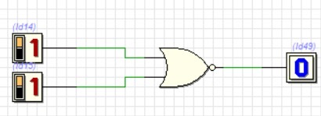

Fig.NOR

Truth table:

|  |  |  |
| --- | --- | --- |
| INPUT | INPUT | OUTPUT |
| 0 | 0 | 1 |
| 0 | 1 | 0 |
| 1 | 0 | 0 |
| 1 | 1 | 0 |